Application :
Product name: Gypsum Plaster One Coat :

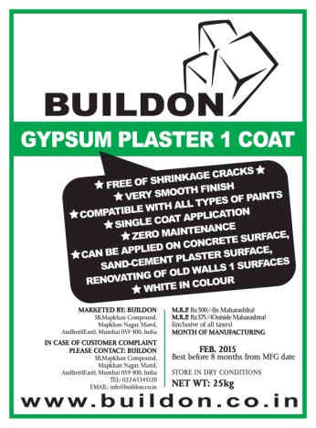
Description :

BUILDON Gypsum Plaster-one coat is that it is made out of the highest grade of Gypsum being pure white in colour and having
a hardness of about 40%, which is more than any other Gypsum
Plaster available in the Indian market. This Gypsum plaster can
be easily applied directly on all surfaces, we do not need to
sand cement and plaster the walls. The coverage in a 25Kg bag
is 20 Sq. Ft. with a thickness of 12mm. The fineness of 250
mesh and purity of over 90% gives the best atomic bond and
an absolute mirror finish.
Fields of application :
- Cement Industry
- Sanitaryware
- Agriculture
- Bandages & dentistry

Technical Specification:

- Purity (whiteness) : 90%
- Fineness : Mesh 250, Residue 3%
- Setting Time Initial : 12 – 15 min.
- Setting Time Final : 24 – 30 min.
- Bending Strength (Dry): 50 Kg / Cm2
- Compressive Strenght (Dry): 133 KG / Cm2
- Dry Bulk Density : 750 Kg / m3
- Coverage at 12mm Thickness (25 Kg bag) : 20 Sq. ft.

- Surface must be clean, dry, firm & free of dust
- Important properties like soluble salt content, thermal characteristics, shrinkage, strength, suction bonding properties etc. of the background which is to plastered, should be evaluated before application.
- Gypsum plaster 1 coat can be applied directly on most of the surfaces like Brick wall / Fly ash brick / Siporex blocks / Concrete surface / Sand cement plaster wall etc.
- Suitable fixture can be fixed after the plaster has set, you can put up fixtures of varying weights. Smaller ones can be supported by using steel hooks and pins, while heavier frames and objects can be accommodated with plugs and screws, or suitable fixtures, adequately penetrated in to the background to ensure firm hold.
Direction Of Use :
:

- The right way to mix is to add powder to water not water to powder.
- Avoid mixing more powder that can be used within 12 - 15 minutes.
- Do not tamper or mix fresh material once a mix has started to set.
- After taking the required amount of plaster, always fold the open end,to protect the plaster from moisture.
- Setting time cannot be altered by diluting the mixture with water.
- For longer setting time BUILDON retarder should be added.
ASTM & Code Standards:
:

- Confirms to IS : 2547 Part 1 & 2

Shelf Life :
:

- Eight months from Date of Manufacturing

Technical Assistance :

Buildon Plasters Pvt. Ltd.
3b ,Mapkhan Compound, Mapkhan Nagar, Marol Maroshi Road, Andheri – East, Mumbai – 400059.
Tel : 022 29200565/569
Email : info@buildon.co.in
Website : www.buildon.co.in

